Alg 3 Summer Name: ____________________________

______________ _____________

WS Assessment

Target 10:

Transformation functions

**I can:**

* Transform graphs using changes in a, h, and k.
* Find the exact equation of a transformed graph given the locator point and another point on the graph
* **Unit 4: Parent Graphs & Their Transformation**

#### [HSF.IF.B.4](http://www.corestandards.org/Math/Content/HSF/IF/B/4/): For a function that models a relationship between two quantities, interpret key features of graphs and tables in terms of the quantities, and sketch graphs showing key features given a verbal description of the relationship. *Key features include: intercepts; intervals where the function is increasing, decreasing, positive, or negative; relative maximums and minimums; symmetries; end behavior; and periodicity*.*

#### [HSF.IF.C.7](http://www.corestandards.org/Math/Content/HSF/IF/C/7/): Graph functions expressed symbolically and show key features of the graph, by hand in simple cases and using technology for more complicated cases.*

#### [HSF.IF.C.7.B](http://www.corestandards.org/Math/Content/HSF/IF/C/7/b/): Graph square root, cube root, and ~~piecewise-defined functions, including step functions~~ and absolute value functions.

* [**HSF.BF.B.3**](http://www.corestandards.org/Math/Content/HSF/BF/B/3/): Identify the effect on the graph of replacing *f*(*x*) by *f*(*x*) + *k*, *k* *f*(*x*), *f*(*kx*), and *f*(*x* + *k*) for specific values of *k* (both positive and negative); find the value of *k* given the graphs. Experiment with cases and illustrate an explanation of the effects on the graph using technology. *Include recognizing even and odd functions from their graphs and algebraic expressions for them.*

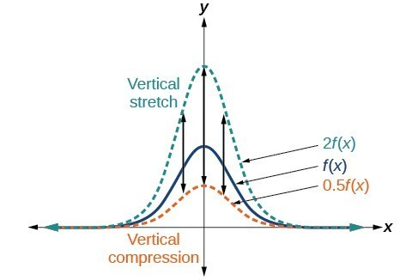Vertical Stretches and Compressions

When we multiply a function by a positive constant, we get a function whose graph is stretched or compressed vertically in relation to the graph of the original function.

If the constant is greater than 1, we get a ***vertical stretch***  f(x) 🡪 **a** f(x) (a > 1)

if the constant is between 0 and 1, we get a ***vertical compression***. f(x) 🡪 **a** f(x) (0< a < 1)

What if a < 0 ?

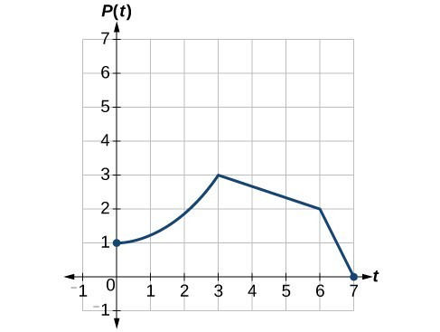Given function P(t) as show, graph function Q(t) = 2P(t) and R(t) = ½ P(t)

Recognizing a Vertical Stretch

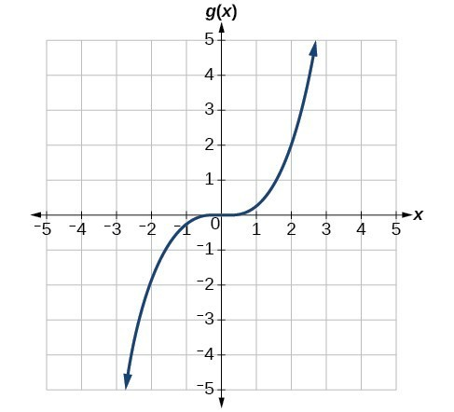

The given graph is a transformation from function f(x) = x3. Identify the stretch factor of g(x)

Identify the stretch factor. (Show work) graph both for stamps

|  |  |
| --- | --- |
|  |  |
| Transform from $f\left(x\right)=\sqrt{x}$ | Transform from |

Horizontal Stretches and Compressions

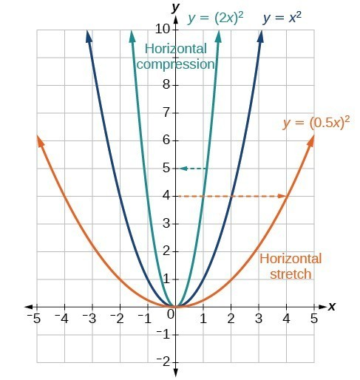

f(x) 🡪 f(bx) where b > 1 horizontal stretch

f(x) 🡪 f(bx) where 0 < b < 1 horizontal compress

What if b < 0 ?



Given function P(t) as show, graph function Q(t) = P(2t) and R(t) = P( ½ t)

Transformation of parabola

Identify the transformation of the following from the parent graph f(x) = x2. Graph to check.

g(x) = 2(x – 2)2 – 3 h(x) = ½ (x + 2)2 + 3 k(x) = 3(x – 3)2 – 2

Write the transformed function for the following from parent graph, using the locator vertex and point (1,1)

|  |  |
| --- | --- |
|  |  |
|  |  |
|  |  |

Identify the transformation of the following from the parent graph f(x) = x2. Graph to check. (Hint: Convert to vertex form first)

f(x) = x2 – 4x + 6 f(x) = -.5x2 + 2x – 1

f(x) = 4x2 – 32x + 61 f(x) = -x2 – 8x – 20

f(x) = 4x2 + 24x + 35 f(x) = -2x2 + 16x – 28

Write the transformed function for the following from parent graph f(x) = | x |, using the locator vertex and point (1,1)

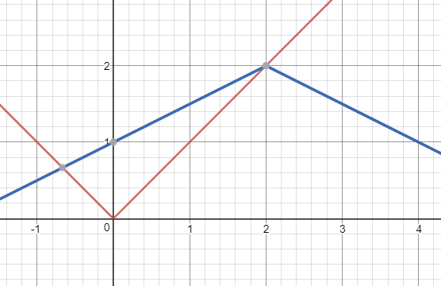

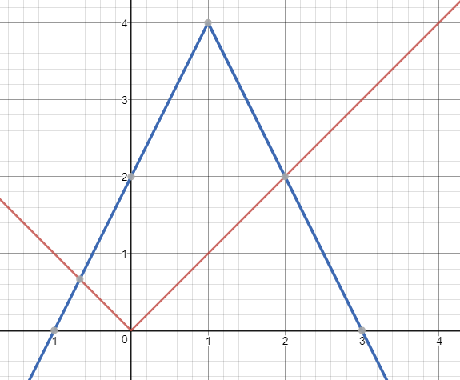

**Assessment Target 10**

**I can…** identify the transformed function using a, h and k

Given the function graph P(t) as shown. Show work and graph

The vertical stretch function Q(t) = 1.5 P(t)

The horizontal stretch

R(t) = P(1.5t)

Write the transformed function for the following from parent graph y = x3, using the locator vertex and point (1,1). Show me for stamp

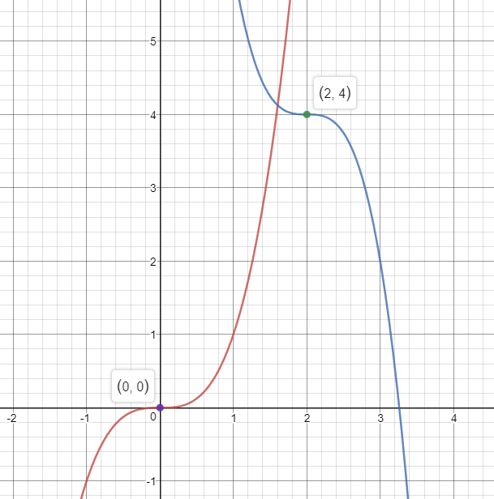

Describe the transformation $g\left(x\right)=\frac{-1}{2}x^{2}+4x-4$ from the parent parabola f(x) = x2